**Mancala Game Board Layout ScreenShot**

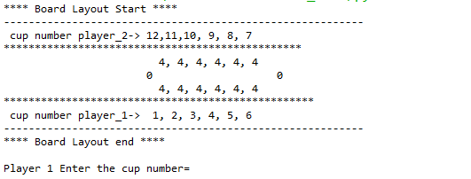

1. The System Prompts the user to enter the cup number, the cup holds four marbles initially.
2. Player one Has cup number marked 1,2,3,4,5,6
3. Player two has cup number marked 12,11,10,9,8,7 , any invalid entry will prompt the warning message to the player